**JULIAN KYULA MINISTRY GLOBAL JKMG Introduction**

The **JKMG App** is a comprehensive digital ministry platform designed to foster spiritual growth, discipline, and global community engagement. The app integrates cutting-edge technology with biblically grounded content to deliver personalized prayer experiences, discipleship resources, and real-time event access. Serving as a virtual extension of Julian Kyula Ministry Global, the app empowers users to cultivate consistent spiritual habits, access prophetic teachings, and connect with a worldwide community of

believers.

**Core Identity**:

• A dynamic tool for **prayer, learning, and fellowship** anchored in Scripture.

• A global hub for JKMG events, resources, and ministry initiatives.

•

Available on Android and IOS, supporting multilingual access (English, Swahili, French,

Spanish).

**Objective**

The JKMG App aims to:

1. **Cultivate Spiritual Discipline**:

o Automate daily prayer routines through the Rhema Prayer Plan and mandatory midnight sessions (Deeper in Prayer).

o Encourage 7-day focused prayer commitments for specific life categories (e.g.,

healing, marriage).

2. **Facilitate Salvation & Discipleship**:

o Guide users to salvation or rededication via the Salvation Corner, with follow-up

resources for new believers.

o Provide structured growth paths through eBooks/Audiobooks, devotionals, and counseling.

**3. Amplify Global Community Engagement**:

o Streamline access to JKMG events (e.g., Rhema Feast, weekly Rhema

Experience).

o Enable testimony sharing and real-time participation metrics (e.g., global prayer counters).

**4. Support Ministry Sustainability**:

o Simplify partnerships/donations via integrated payment gateways (M-Pesa, Bank, Send wave).

o Drive data-driven decisions through analytics on user engagement and content impact.

**Scope**

**The JKMG App encompasses a wide range of spiritual and technical features including:**

• **Prayer Engagement:** Personalized prayer intervals, midnight prayer sessions, and 7-day

prayer commitments.

• **Spiritual Resources:** Access to downloadable eBooks and audio books in multiple languages.

• **Live Events Integration:** Rhema Feast, Rhema Experience, and other ministry

broadcasts.

• **Discipleship & Counseling:** Salvation experiences, testimonies, mental health support, and mentorship tools.

• **Community Features:** Announcements, testimonies, donations, news, and Kingdom

Commonwealth linkages.

• **Administrative Dashboard:** Real-time analytics, user activity tracking, prayer session

statistics, and partner support data.

**Target Audience**

• Christians globally seeking deeper spiritual intimacy

The app will have an Introduction from the website what JKMG is about and what it represents

(<https://rhema-website-khaki.vercel.app/>)

**User Sign-in Page**

**JKMG Logo:**

****Standard log-in page that should include country and check box for agree to Terms and conditions as well as a check-box for marketing information. Terms and conditions check-box should be mandatory

**Components:**

1. **Client App (React Native):**

o UI Components

o Notification Handler

o Audio Player

o

Local Cache

2. **Backend Services (Node.js):**

o User Service: Profile management

o Prayer Service: Content delivery

o Scheduler Service: Cron-like system

o Analytics Service: Session tracking

**THE THEME OF THE APP IS BLACK AND GOLD.**

**Once a user logs on they should see sliding photos shared which will be editable based on future events: use below photos and an introductory video**

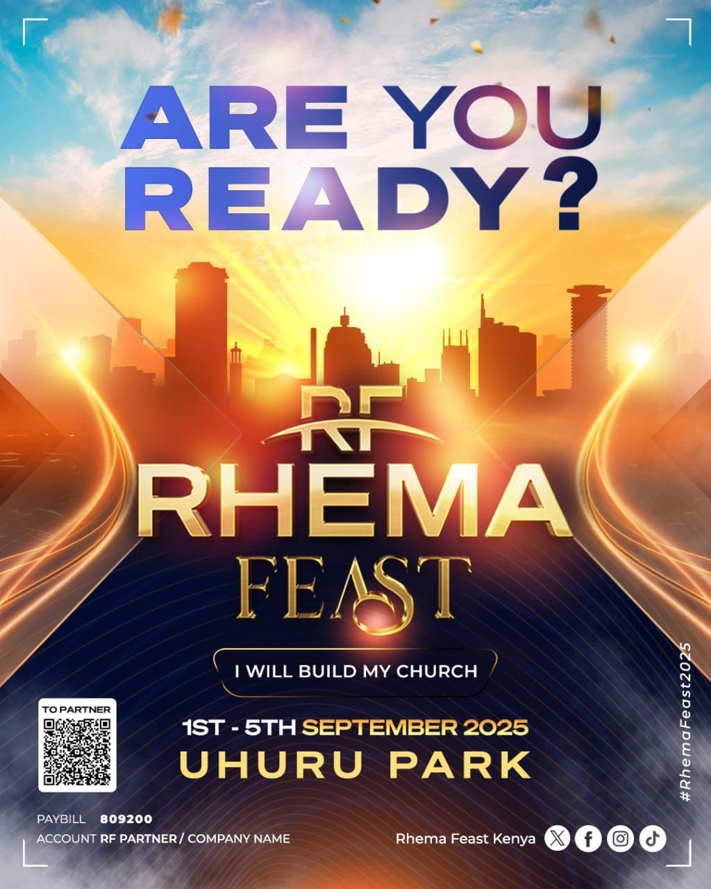

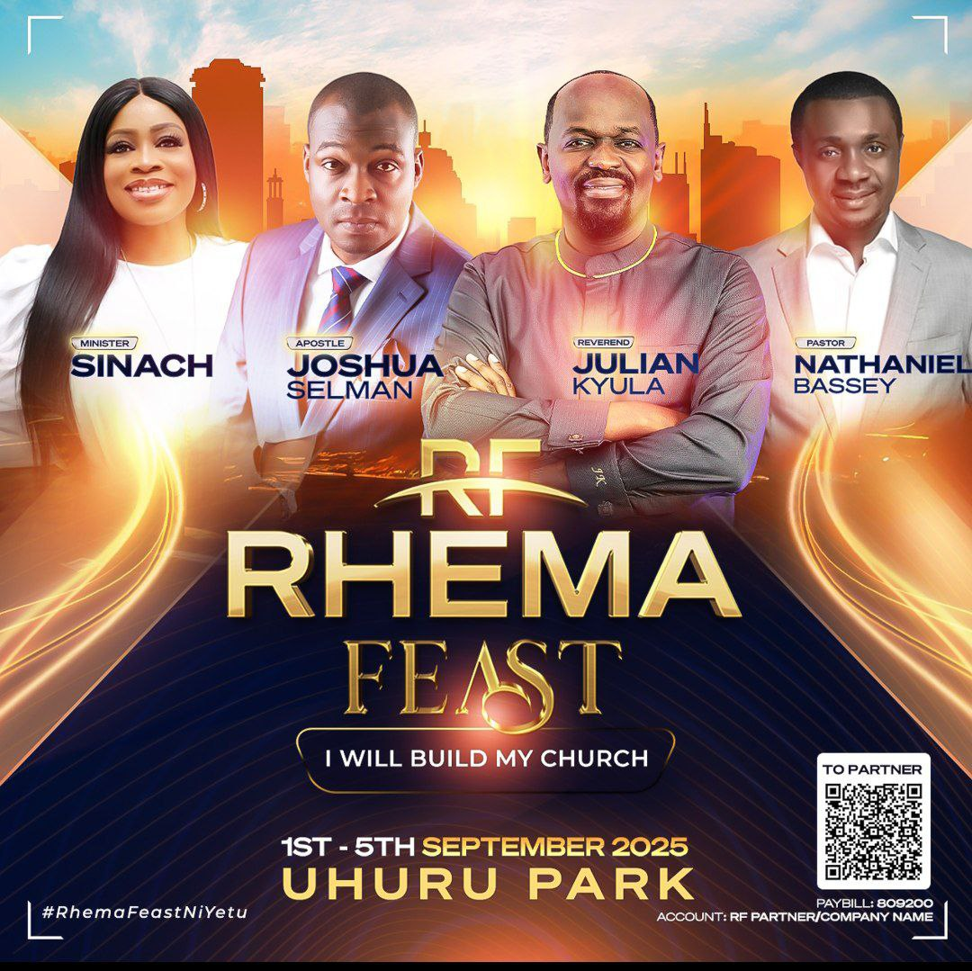



# MENU NUMBER ONE (1): ABOUT



**(On the introduction there will be a place for the pre-recorded welcome voice from the pastor)The video should be sliding**

Julian Kyula Global Ministries (JKGM) is a faith-driven movement dedicated to transforming lives and nations through the power of God’s Word, apostolic insight, and marketplace impact. Founded by Reverend Julian Kyula, this global ministry exists to equip individuals, leaders, and communities to thrive in their divine purpose across the mission field, ministry work, and the marketplace. Through inspired teaching, prayer, strategic gatherings, and practical outreach, we are raising a generation of kingdom-minded believers who are bold, innovative, and grounded in truth. JKGM is committed to seeing lives restored, systems reformed, and God’s glory revealed across the earth whether through global conferences, media outreach, church planting, or economic empowerment initiatives,

# VISION

To build a world where spiritual leadership, innovation, and enterprise work together to restore dignity, equity, and opportunity to underserved communities globally.

# MISSION

To empower individuals, transform communities, and influence systems by strategically integrating faith, leadership, and sustainable development through impactful alliances.

# CORE GOALS

1. Advance the Gospel through modern, relevant ministry.
2. Solve systemic community challenges via kingdom-driven enterprise.
3. Create equitable opportunities in education, finance, health, and innovation.
4. Mobilize strategic alliances for high-impact social transformation.

**ABOUT JULIAN KYULA:**

Rev. Julian Kyula serves as the founder and overseer of Ruach Ministries, originally established in 2007 as The Purpose Centre Church. Renowned for his expertise and leadership, he is a widely recognized entrepreneur and influential thinker, with a notable impact across Africa and globally.

In 2010, Julian launched the MODE Group, a highly successful multinational fintech corporation that swiftly ascended to prominence as a frontrunner in cashless microservices. Operating in over 14 African nations and 26 countries worldwide, the MODE Group emerged as a powerhouse in the industry, amassing significant financial success.

Presently, Julian holds the position of Chairman at Beulah City Ltd, among other ventures. Founded with the aim of spearheading housing developments throughout Africa, Beulah City stands out by offering upscale housing solutions at accessible prices, catering to the burgeoning middle class.

Notably, Julian played a pivotal role in brokering an agreement at the United Nations General Assembly in New York in 2019. This agreement, between the government of Kenya and UNOPS, pledged to deliver 100,000 affordable houses as part of Kenya’s Big 4 Initiative.

Julian is married to Amanda Kyula, and together they are proud parents of three sons.

# MENU NUMBER TWO (2): RHEMA PRAYER PLAN

Intro- **"Welcome to the Rhema Prayer Plan — a daily prayer schedule designed to keep you aligned in prayer every 6 hours, led by Rev. Julian**."



The JKM App introduces an innovative **Prayer Plan** feature designed to integrate spiritual discipline seamlessly into users' daily routines. Functioning as an alarm notification system, this feature ensures consistent prayer engagement by providing timely reminders and guided prayer sessions led by Rev. Julian Kyula.

The prayer Plan should have three sub-menus

1. **Prayer Schedule** – intro ("**This schedule is designed to send prayer reminders every 6 hours—at 6:00 AM, 12:00 PM, and 6:00 PM. At each interval, you'll receive a notification prompting you to join Rev. Julian Kyula in prayer. Each session will last between 10 to 20 minutes, depending on the leading of the Holy Spirit.**
2. **Request Prayer** – intro - **"This feature offers users personalized spiritual support by allowing them to select a specific prayer focus based on the life challenge they are facing. Once chosen, the prayer request remains fixed for a 7-day period to encourage consistency and focused intercession.During these 7 days, users are encouraged to engage in daily prayers and fasting—either from 6 AM to 3 PM or 6 AM to 6 PM—while following the scheduled prayer notifications every 6 hours. This structured approach promotes disciplined, faith-filled engagement and deeper spiritual growth."**
3. **Deep in Prayer** – intro **"As the name suggests, this feature is designed to facilitate a powerful midnight prayer session from 12:00 AM to 1:00 AM (local time), for users seeking spiritual growth and a deeper encounter with God. Led by Rev. Julian Kyula, each 30 to 60-minute session includes scriptural prayer points, prophetic declarations, and divine alignment—creating a truly transformative midnight worship experience."**
4. **Prayer Schedule** – intro ("**This schedule is designed to send prayer reminders every 6 hours—at 6:00 AM, 12:00 PM, and 6:00 PM. At each interval, you'll receive a notification prompting you to join Rev. Julian Kyula in prayer. Each session will last between 10 to 20 minutes, depending on the leading of the Holy Spirit.**

**Key Features:**

1. **Personalized Prayer Schedule:**

* Upon registration, users will set their preferred prayer intervals, selecting a frequency

between **6am, 12pm and 6pm**.

* The chosen interval is saved within the app, ensuring automatic reminders at the scheduled times.

2. **Alarm Notification System**

* Users receive an alert when it’s time to pray, prompting them to accept or defer the session.
* Upon acceptance, the app initiates an **audio-guided prayer session** featuring Rev. Julian Kyula.
* Users receive an alert when it’s time to pray, prompting them to accept or defer the session.
* Upon acceptance, the app initiates an **audio-guided prayer session** featuring Rev. Julian Kyula.

**Notification preferences:**

* Sound selection (Chime/Bell/Scripture recitation) etc.
* Vibration patterns
* LED color for notifications

**User options**

o Accept button: Immediate session start

o Defer button: Options panel slides up

1. 5/10/15 minute deferral buttons

2. "Snooze until tomorrow" option

**Deferral processing:**

* new schedule time = current time + deferral minutes
* Update scheduler queue
* Local notification scheduled

**Automatic time zone detection:**

* GPS location permission request
* Manual override option

**Exemption handling**

**Scenario 2: Deferred Session**

• Max deferrals: 3 per session

• After 3 deferrals: Auto-cancel

•

Reschedule at next interval

**Collected Metrics:**

1. Session start/end times

2. Actual vs scheduled duration

3. Deferral frequency

4. Completion rates

5. Popular prayer durations

6. Time zone distribution

**Request A Prayer (Prayer Category)**

1. **Request Prayer – intro - "This feature offers users personalized spiritual support by allowing them to select a specific prayer focus based on the life challenge they are facing. Once chosen, the prayer request remains fixed for a 7-day period to encourage consistency and focused intercession. During these 7 days, users are encouraged to engage in daily prayers and fasting—either from 6 AM to 3 PM or 6 AM to 6 PM—while following the scheduled prayer notifications every 6 hours. This structured approach promotes disciplined, faith-filled engagement and deeper spiritual growth."**

The **"Request A Prayer”** provides users with personalized spiritual support by allowing them to choose on a prayer request in specific life categories. This structured approach ensures focused, faith-filled intercession while encouraging disciplined prayer engagement over a 7-day period.

**Key Features:**

1. **Prayer Category Selection:** Users select **one** prayer category from a predefined list, including:

▪

**Blessings**

▪ **Healing**

▪ **Marriage**

▪ **Protection**

▪ **Spiritual Growth etc**

2. **7-Day Prayer Commitment:**

o

After selecting a category, users **cannot submit another request until completing a 7-day**

**prayer cycle**.

o User will receive an **audio-guided prayer session (15 minutes)** tailored to their chosen category with scripture-based prayer points backed by Bible verses**,** delivered in Rev. Julian’s voice for

spiritual alignment.

o The session concludes with a **prayer of agreement**, sealing their petition in faith.

**Deeper in Prayer**

1. **Deep in Prayer – intro "As the name suggests, this feature is designed to facilitate a powerful midnight prayer session from 12:00 AM to 1:00 AM (local time), for users seeking spiritual growth and a deeper encounter with God. Led by Rev. Julian Kyula, each 30 to 60-minute session includes scriptural prayer points, prophetic declarations, and divine alignment—creating a truly transformative midnight worship experience."**

The **"Deeper in Prayer"** feature is a **mandatory** extension of the Rhema Prayer Plan, designed to facilitate powerful **midnight prayer sessions** (12 AM – 1 AM, local time) for users seeking a deeper spiritual encounter. This dedicated prayer time, led by Rev. Julian Kyula, provides **30- minute or 1-hour** sessions filled with **scriptural prayer points, prophetic declarations, and divine alignment**, ensuring a transformative midnight worship experience.

**Key Features:**

**1. Automatic Time Zone Adjustment:**

• The app detects the user’s location and **synchronizes midnight prayer (12 AM –**

**1 AM)** based on their local time.

• Ensures consistency for users across different regions.

**2. Structured Midnight Prayer Sessions:**

• Users can choose between a 30-minute or 1-hour prayer duration.

• Upon accepting the notification, Rev. Julian Kyula’s voice guides them through:

• Scripture-Based Prayer Points (aligned with spiritual warfare and breakthrough).

• Prophetic Declarations (decreeing God’s promises).

• Corporate Agreement Prayer (uniting in faith with a global prayer community).

**3. Mandatory Participation (Post-Setup):**

• Once a user activates the Rhema Prayer Plan, **"Deeper in Prayer"** becomes a compulsory spiritual discipline.

• Encourages consistency in **late-night spiritual encounters**, and prayer model

**Metrics Captured:**

1. Conversion funnel drop-off points

2. Average time in prayer experience

3. Resource download rates

4. Geographic distribution

5. Anonymous demographic trends

# MENU NUMBER THREE (3): BIBLE STUDY CORNER



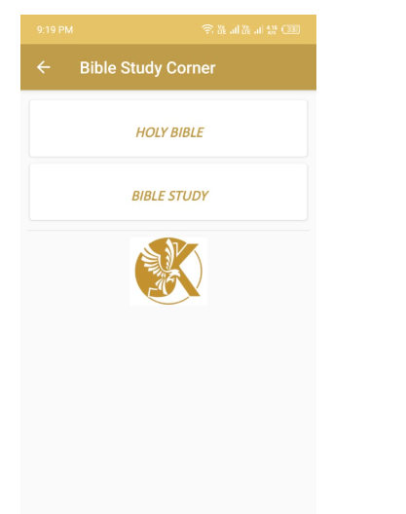

Holy Bible: we will share list of Bible Json files

Bible study corner template: The template should be populated in the back-end and show on the front end with the same format below;

|  |  |
| --- | --- |
| Memory Verse | Input Field / Description |
| Topic of the Day | Enter or select the main theme for today’s Bible study. |
| Scripture of the Day | Enter or paste the Bible verse or passage. Example: |
| Devotional Summary | Write a short devotional or explanation (2–3 paragraphs). |
| Group Discussion Questions | Add 2–3 reflective or discussion questions based on the scripture. |

# MENU NUMBER FOUR (4): SALVATION CORNER:



**Salvation Corner** – intro (**"If you’d like to give your life to Christ, rededicate your life, or share a testimony, please select one of the options below to proceed."**)

1. **Give My Life to Christ –** intro (**"As the name suggests, please complete and submit the form below. You will receive a pre-recorded voice message from Rev. Julian, personally leading you to Christ."**)
2. **Rededicate My Life To Christ** - intro- (**"As the name suggests, simply fill out and submit the form below. You will receive a pre-recorded voice message from Rev. Julian, guiding you in rededicating your life to Christ."**)

**\*\*\*\* ( Kindly note the function of having prerecorded voice sent to the inbox of users who have filled the form )**

1. **Testimonies – Intro – ("As the name suggests, please fill out and submit the form below to share your testimony of what God has done for you through the JKMG platform.").**

**\*\*\*\* For Dev ( Pls kindly apply make it possible for testimonies that would be shared under this sub menu have the ability to slide automatically like 2 seconds interval with users able to pause slides and read at any giving time. )**

# MENU NUMBER FIVE: COUNSELING AND CARE



Chat with a Christian Mental Well-Being Assistant on.

https://studio.pickaxe.co/api/embed/bundle.js

**Access Point: Home Screen > Counseling & Care**

• Clearly visible card or banner titled:

Counseling & Care – Find Healing in Christ

**Example Labels / CTA Buttons:**

Counseling and Care – **intro – "Welcome to our Counseling and Care Department. Your emotional, spiritual, and overall well-being matter deeply to us as a ministry. Please select the option below that best fits your specific need."**

1. Access Counseling – **Intro**- **"Click the link below to join our private Telegram group, where you’ll have direct access to our dedicated and professional care team. You can share your concerns privately and also schedule a one-on-one call for personalized support." Please add a booking calendar that shows available booking slots.**

Example

**Book a Counseling Session**

Tap Book a Session

Choose focus area:

Anxiety, Depression, Addiction, Grief, Family, Identity, Healing, Spiritual Growth etc.

Fill short intake form (optional)

Confirm booking

**Emergency Help Flow (Crisis Support)**

For users in distress or with suicidal thoughts

**1. Tap “Need Urgent Help?”**

2. Immediate AI detection of keywords (e.g., “I want to die,” “I feel lost”)

3. Prompts options:

o Call JKM Prayer Line (linked to ministry hotline)

* Connect with live counselor
* Scripture + prayer instantly shown
* Escalates to senior pastoral support team if needed

1. **(Self-Guided Healing) "As the name suggests, this section of the app is designed to provide answers to your pressing questions, supported by relevant Bible verses. Powered by our custom AI agent (GPT), it offers clarity, guidance, and spiritual direction tailored to your needs."**

**i.e Devotional Therapy**

• Short, guided 5–15-minute daily devotionals

• Topics like:

o Healing from Church Hurt

o Overcoming Fear with Scripture

o Letting Go of Shame

AI suggests relevant verses and a prayer

• Encourages journaling (kept in user’s "Healing Journal")

• Optional audio by Rev. Julian or JKM counselors

**B. Voice-Guided Prayers & Meditation**

• Examples:

o Prayer for Mental Peace.

o Healing from Past Trauma.

o Victory over Depression.

• With calming music & Scripture overlay

**Mood Tracker with Bible Prompts**

* Daily check-in:
* How are you feeling today?

1. Feedback – **Intro- "As the name suggests, this section invites you to share your experience and feedback regarding your interactions with our counselors and dedicated AI agent. Please take a moment to fill out the form below and share your thoughts." Add a feedbackform**

**Testimony & Breakthrough Section**

Social proof and encouragement

• Users (optional) submit testimonies of emotional or spiritual healing

• Displayed after ministry approval

•

Encourages others to believe for restoration

**Admin & Counselor Panel (Back-End)**

For JKM’s trained team to manage the care unit:

• View upcoming bookings

• Respond to live chats

• Access users’ intake forms (if consented)

•

Assign prayer requests

•

• Upload devotionals, audio content

• Flag and follow-up on emergencies

Analytics: # of sessions, trending emotional issues, testimonies

# MENU NUMBER SIX (6) JKMG RESOURCES



**Welcome to this section, where you can access both digital and physical resources from Rev. Julian Kyula and the JKMG brand."**

* JKMG Digital Materials – intro- **"Gain free access to Rev. Julian’s wealth of wisdom—both in spiritual matters and marketplace leadership—through downloadable content including eBooks, audiobooks, and recorded messages."**

1. Audio Books & E-books (this is typically the same because whatever u read on the e-book is what has been transcribed into audio book.
2. Audio Sermons (Kindly include area for topic and date)

* JKMG Merchandise – intro - **"Explore a range of JKMG-branded products—from hoodies and sweaters to mugs and more. Click the link below to view the full collection. You’ll also find a shipping and logistics form—please ensure all details are filled in accurately to help us deliver your purchase successfully." The link you will add would be the one I shared for the website.**

# MENU NUMBER SEVEN (7): EVENTS AND ANNOUNCEMENTS:



**Events & Announcement** – intro - **"Here you’ll find up-to-date information on the various expressions and gatherings offered by JKMG—ranging from ministry-focused events to marketplace initiatives."**

1. **Rhema Feast** – Intro -**Rhema Feast is a landmark annual spiritual gathering that began in 2015. As part of an apostolic movement led by visionary leader Rev. Julian Kyula, its mission is to deliver the unadulterated, authentic Word of God to nations and generations. This year’s Rhema Feast will be held from 1st–5th September 2025. Over the course of four days, believers from across the globe will come together to ‘feast’ on God’s Word—engaging in powerful worship, fervent prayer, meaningful fellowship, and, new this year, marketplace and business coaching. This added dimension empowers believers to integrate their faith with their professional lives for maximum Kingdom impact. Rooted in four core pillars—***Word, Worship, Prayer, and Unified Fellowship***—Rhema Feast has grown regionally and internationally. It continues to ignite spiritual revival, mentor seekers, and meet the rising global hunger for God’s presence and truth.**

An annual mega gathering hosted by JKMG, featuring the prophetic word, worship, and impartation.

**Process Flow:**

**1. Home > Rhema Feast Section**

2. Landing Screen:

o Hero Banner (Event Name, Date, Theme)

o Promo Video or Testimonial Clips

o

“Register Now” CTA

3. **User Registration Flow** o Tap “Register” o Fill form:

▪ Name

▪ , Email, Phone

Country, Church Name (Optional)

Atten▪ dance: Physical / Online

Volun▪ teer: Yes/No

o Receive Confirmation sms

4. **Pre-Event Countdown Dashboard**

o Days left

o Speakers list

o

Schedule preview

o Location map integration

o “Invite a friend” (share button)

5. **During the Event**

o Live Stream Button (if online)

o Session notes / e-book access o Session feedback forms

6. **Post-Event**

o “Watch Again” Video Archive

* Post-event survey
* Testimony
* Donation appeal

1. **RXP (Rhema Experience)** – intro - **"RXP" stands for *Rhema Xperience*—an interdenominational weekly service held at Ruach Assemblies (Purpose Centre Church) in Nairobi, led by Rev. Julian Kyula. Rooted in the Greek word *Rhema*, meaning 'the spoken word of God,' the service is designed to usher believers into a deep encounter with the power of God’s Word. "Ruach," a Hebrew term meaning wind, breath, or spirit, reflects the presence and move of the Holy Spirit. RXP**

**takes place every Wednesday at 5 PM at All Saints Cathedral, Nairobi—offering a powerful atmosphere of worship, prophetic teaching, and spiritual transformation."**

**Rhema Experience (RXP) – Midweek Prayer Service Flow**

A transformative weekly interdenominational worship experience.

**Process Flow:**

**1. Home > Rhema Experience**

2. Overview Screen:

o Title: “Join Us Every Wednesday”

o Time & Venue: 5:00–9:00 PM @ All Saints' Cathedral o “Directions to Venue” (Maps link)

**3. Service Reminders**

o Users’ opt-in to:

▪ Push Notifications (“Service is starting in 1 hour”)

▪ Calendar sync (adds weekly reminders)

**4. Live Stream Access**

o Stream via embedded Ruach YouTube channel

o Live chat feature (optional) for engagement

o Highlighted Scriptures or song lyrics during stream

**5. After-Service Engagement**

o “Share your experience”

o Submit prayer request

o Join small groups or join next physical service

. **Archive Section**

o Past RXP sermon videos

o Audio devotionals from past RXP sessions

o Notes/downloadable if available

1. **JKMG Evangelical Outreach -intro- "Browse the images and video links below to see how God is using JKMG to evangelize and transform lives. This is the heart of our calling and mission."**
2. **7D JKMG Business Forum (JKMG business forum is a structured Physical gathering—where business owners,SMEs, entrepreneurs, investors, and industry professionals come together to exchange ideas, discuss opportunities, share expertise, and build professional networks.**

**It often includes:**

* **Panel discussions or keynote speeches from experts like Rev Julian Kyula.**
* **Networking sessions to connect with potential partners, clients, or investors.**
* **Workshops or breakout sessions for skills development and problem-solving.**
* **The main goal of JKMG business forum is to build faith driven entrepreneurs, promote collaboration, inspire innovation, and create opportunities for growth amongst the Christian business community.)**

# MENU NUMBER NINE (9): PARTNERSHIP AND GIVING

**To partner with the transformative work God is doing through Rev. Julian Kyula and JKMG—whether through financial support or in-kind contributions—please find our giving and contact details below. Thank you, and may God bless you abundantly."**

**** For Dev ( Pls create a clickable form for Mpesa Paybill, Sendwave, Bank Transfers both local and International etc . API would be provided soon)



Financial and spiritual supporters of JKMG.

**Process Flow:**

**1. Home > Partner with Us**

2. Intro Screen:

o Message from Rev. Julian

o Vision of JKMG and impact stories

o Partnership scripture (e.g., Philippians 4:17)

**3. Options:**

o Become a Monthly Partner o One-Time Donation

o Support a Cause (RF, Media, Youth Ministry, etc.)

**4. Donation Flow:**

o Tap “Give Now”

o Choose amount or enter custom o Select method:

▪ **M-Pesa STK push / Pay bill**

Card /▪ Bank Transfer/Send wave / PayPal

o Enter personal info (optional)

o Confirm

o Receive receipt via email/SMS (ken to share customized thank you message and

receipt confirmation)

5. **Partner Dashboard (for registered partners)**

o View giving history

o Update card/payment details o Download giving statements

o Access exclusive partner messages or devotionals

**Testimonies**

Celebrate what God is doing through JKMG

**Process Flow:**

**1. Home > Testimonies**

2. Gallery/Feed View:

o Carousel or tile layout

o

Can filter by category (e.g., Healing, Financial Breakthrough, Deliverance)

**3. Submit a Testimony Flow**

o Tap “Share My Testimony”

o Fill form:

▪ Title Your Name

▪ Story (Text field)

▪ Optionally upload photo/video/audio

▪ Consent checkbox: “I agree to have my story shared”

o Submit

**4. Admin Review & Approval**

o Testimonies not posted automatically

o Admin receives notification for moderation

o Once approved, they go live

**5. Engagement**

o Reactions:

o Option to link testimony to specific event or message

**Admin Panel Access for All Modules**

Each of the above modules connects to the JKMG back-office admin panel where authorized

personnel can:

• Post/edit/delete content

• Monitor registrations

•

Approve donations/testimonies

•

• Push notifications

Track analytics and user engagement

**Contact Section – Process Flow**

Central hub for reaching JKM, sending testimonies, or connecting via social media.

**Process Flow:**

**1. Access: Home > “Contact Us”**

2. Contact Landing Page:

o Headline: “We’d Love to Hear from You”

o Quick Info:

▪ General Inquiries: [info@jkministriesglobal.org](mailto:info@jkministriesglobal.org) Office

Location:

▪ Nairobi, Kenya (with embedded Google Map)

o Icons with links:

▪ Rev. Julian’s verified social media (YouTube, Facebook, Instagram, X)

3. **Contact Form Section**

o Input Fields:

▪ Name

▪ Email

▪ Subject

▪ Message

▪ Dropdown: [Inquiry Type] → General / Testimony / Speaking Invite /

▪ Prayer

▪ Upload file (optional: testimony video/photo) CAPTCHA + consent checkbox

4. **Form Submission**

o Auto-response: “Thank you, we’ll respond within 48 hours”

o Email notification to admin inbox (configurable)

o Contact logs stored in dashboard (searchable by type)

5. **Back-End Admin View**

o Contact log viewer

o Filter: unread / flagged / inquiry type

o

Export to Excel

# MENU NUMBER EIGHT (8) KINGDOM COMMONWEALTH SECTION



Introduce and redirect users to explore the Kingdom Commonwealth platform.

**Process Flow:**

**1. Access: Home > “Kingdom Commonwealth”**

2. Intro Screen:

o Section Title: “Kingdom Commonwealth – A Kingdom Economic Movement”

o 2–3 paragraph description:

▪ What it is

▪ Core mission

▪ Connection to JKMG vision

3. **Multimedia Section (Optional)**

o short intro video or quote by Rev. Julian o Embedded linkable image banners

**Link to External Platform**

Android: **https://play.google.com/store/apps/details?id=com.kingdomcommonwealth.app**

**Website:** **https://www.kingdomcommonwealth.com/**

**See example below:**

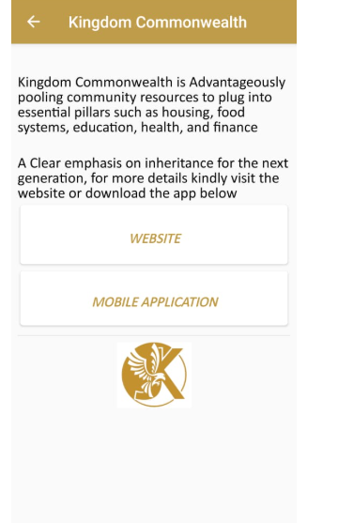

# MENU NUMBER TEN (10)

**COMING SOON**



**Admin Panel Controls**

o Ability to update the external links or description content

**Data Process Flows – Admin & Analytics**

Robust tracking of app usage and engagement for JKM leadership and media team.

Data Tracking Goals

• Understand usage trends

• Measure impact of features/events

•

Inform content strategy

**Analytics Dashboard: Key Metrics**

**A. User Engagement Metrics**

|  |  |
| --- | --- |
| **Metric** | **Description** |
| Daily Active Users (DAU) | Number of unique users who open/use the app per day |
| Weekly Active Users (WAU) Sa | me as above, for the week |
| Monthly Active Users (MAU) | Long-term trend of app retention |
| Session Time | Average duration per user session |
| Bounce Rate | Users who open app and leave immediately |
| Most Visited Modules | Which feature is accessed the most (e.g., Counseling, RXP) |
| Conversion Funnels | E.g., “Rhema Feast Viewed → Registered” |

**B. Feature-Specific Analytics**

|  |  |
| --- | --- |
| **Feature** | **Metrics to Track** |
| Rhema Feast | Registrations, attendance, replay views |
| RXP | Live views, stream duration per user |
| Counseling & Care | # of chat sessions, topics, escalation count |
| Donations | Amount, frequency, preferred method |
| Testimonies | Number submitted, most engaged testimony |
| Push Notifications | Open rate, click-through rate |

**C. User Demographics (Optional)**

|  |  |
| --- | --- |
| **Data** | **Source** |
| Country | Based on IP or profile |
| Age & Gender | If provided during onboarding |

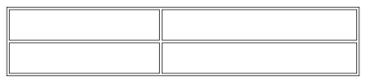

**Data Source**

Denomination/Interest Based on initial app selections

**Admin Panel Functionality (Back-End)**

**Dashboard Widgets**

• DAU/WAU/MAU graphs (line chart)

• Feature Usage Pie Chart

•

Map of active users by region

• ⏱ Session time trends (bar graph)

• Counselor usage heatmap

**ExportOptions**

• Daily, weekly, monthly reports

• Export to Excel / PDF

•

Admin email scheduling for weekly analytics digest

**Data Source**

• All analytics powered via:

o Firebase / Mixpanel / Google Analytics for Firebase o Custom event tagging for each feature

o Data stored securely for ministry reporting

**Suggested Admin User Roles**

|  |  |
| --- | --- |
| **Role** | **Permissions** |
| Super Admin | Full access, user management |
| Media Admin | Upload content, manage news/testimonies |
| Counselor Admin | Manage chats, view user reports |
| Finance Admin | View donations/partners only |
| Event Manager | Manage RF, RXP, user registrations |

35 | Page